Name: SANKALP VERMA

User Assignment – 2

Problem Statement: (Other Key SQL Statements)

1. Insert into employee table with some more records.

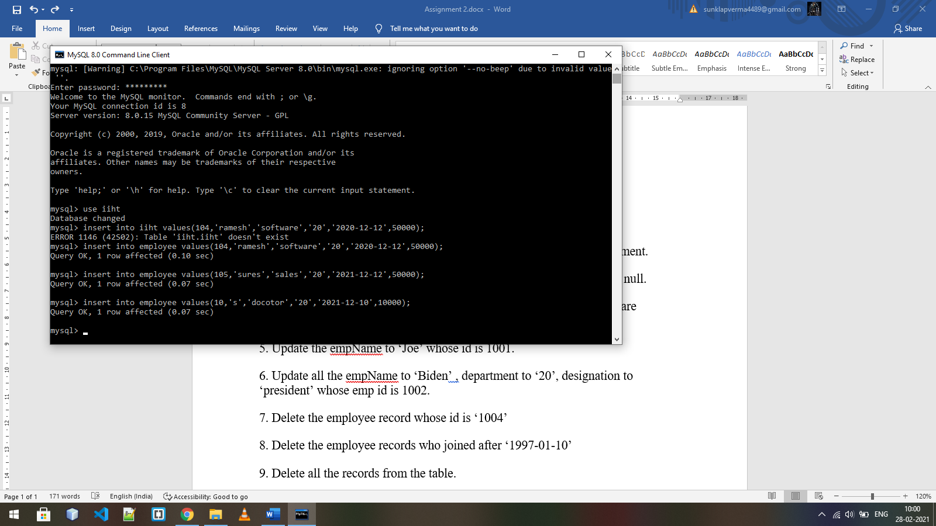

2. Insert into employee table for only id, empName, designation, department.

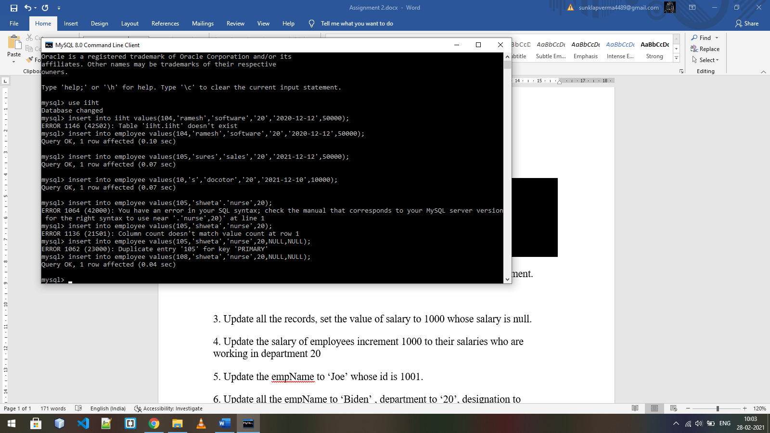

3. Update all the records, set the value of salary to 1000 whose salary is null.

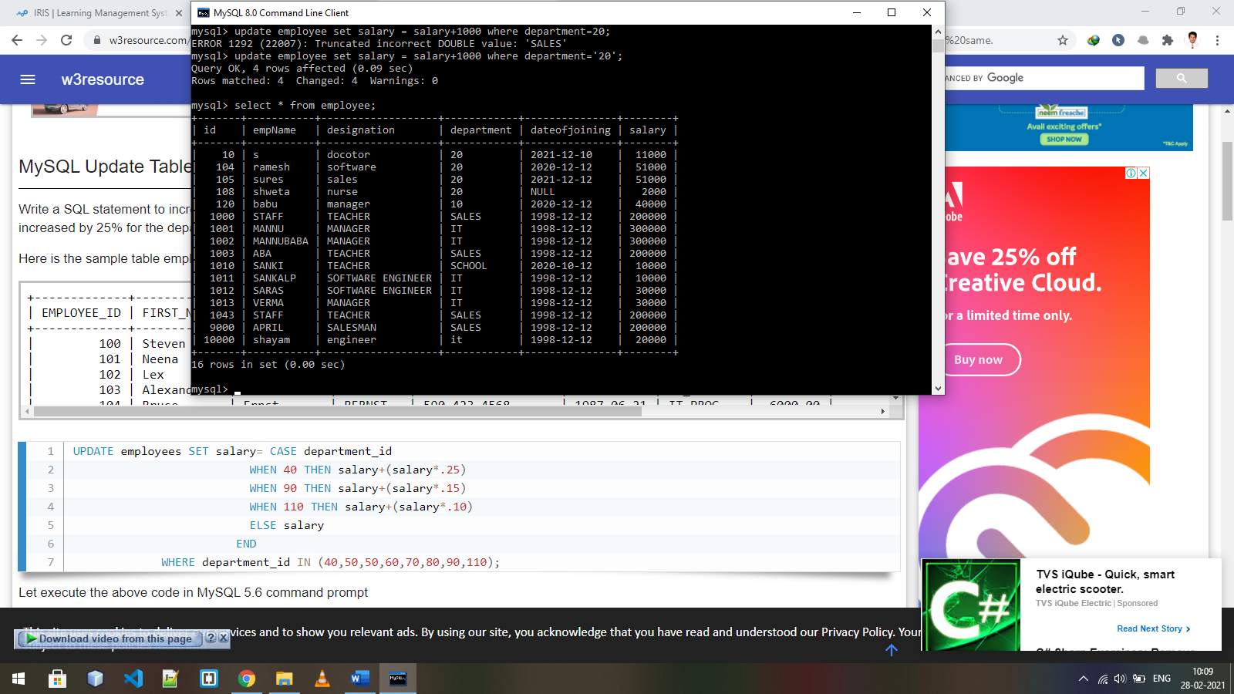  
4. Update the salary of employees increment 1000 to their salaries who are working in department 20

5. Update the empName to ‘Joe’ whose id is 1001.

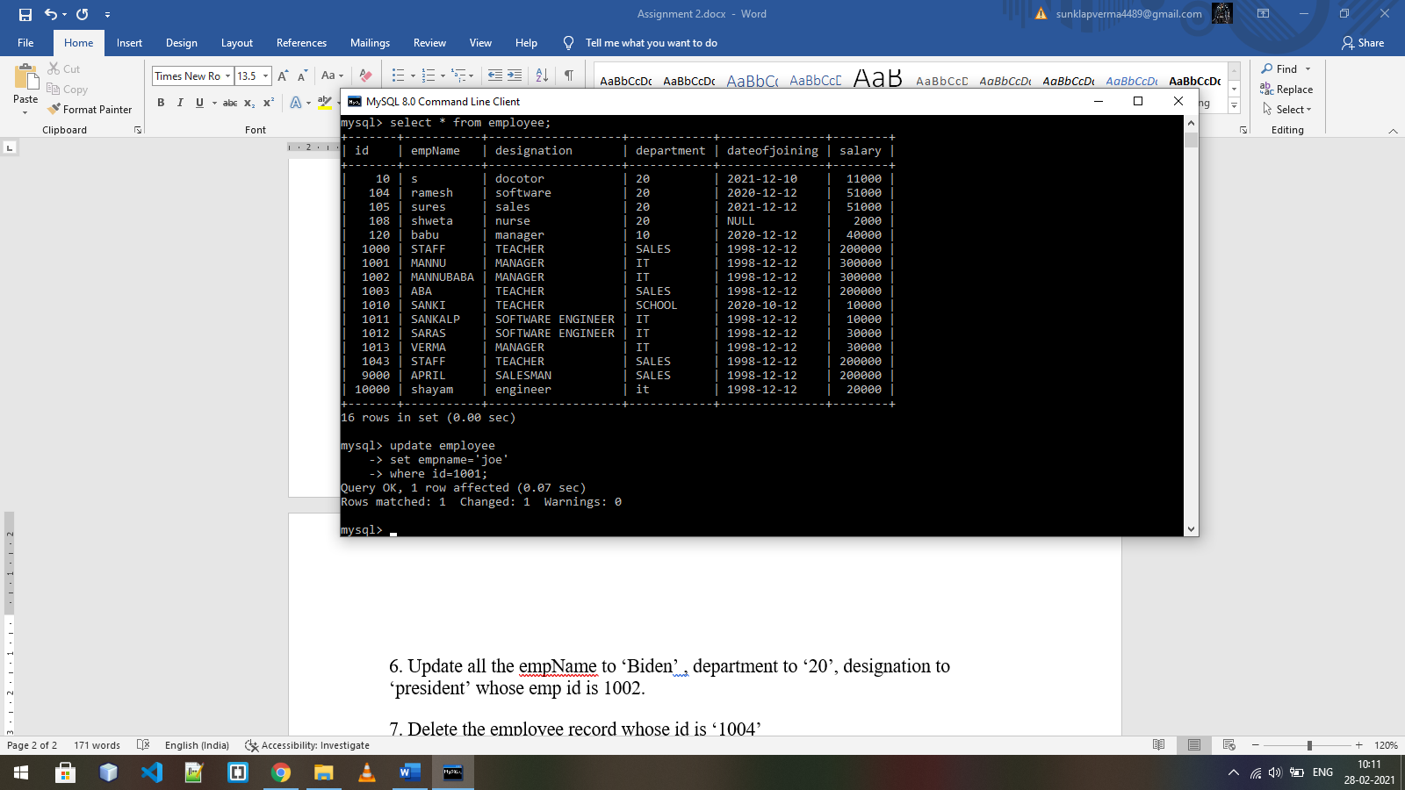  
6. Update all the empName to ‘Biden’ , department to ‘20’, designation to ‘president’ whose emp id is 1002.

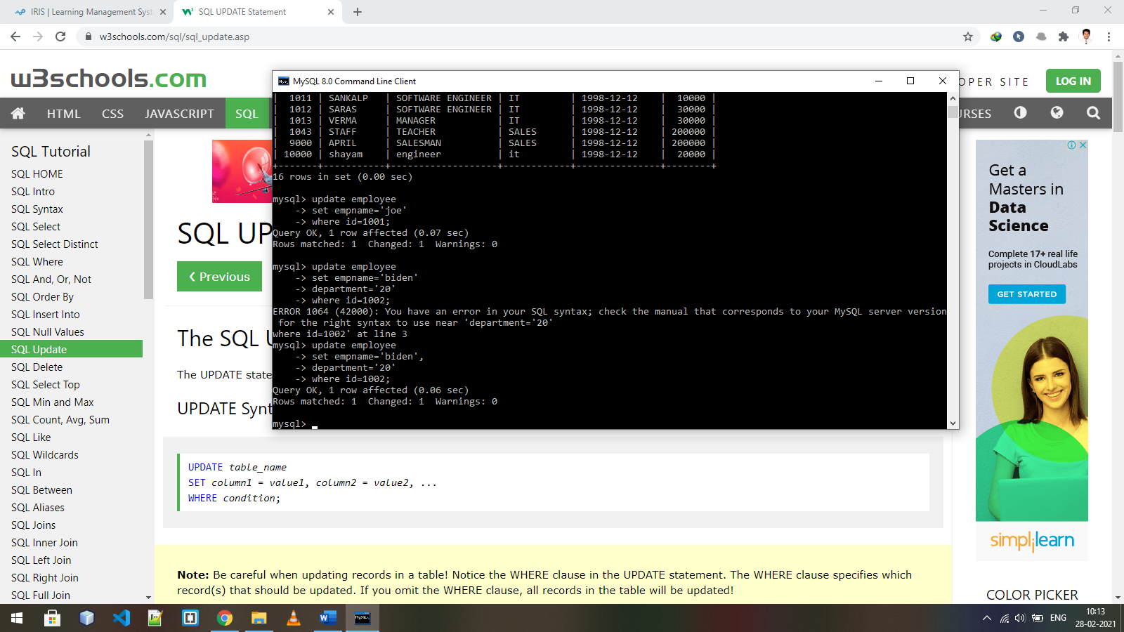

7. Delete the employee record whose id is ‘1004’

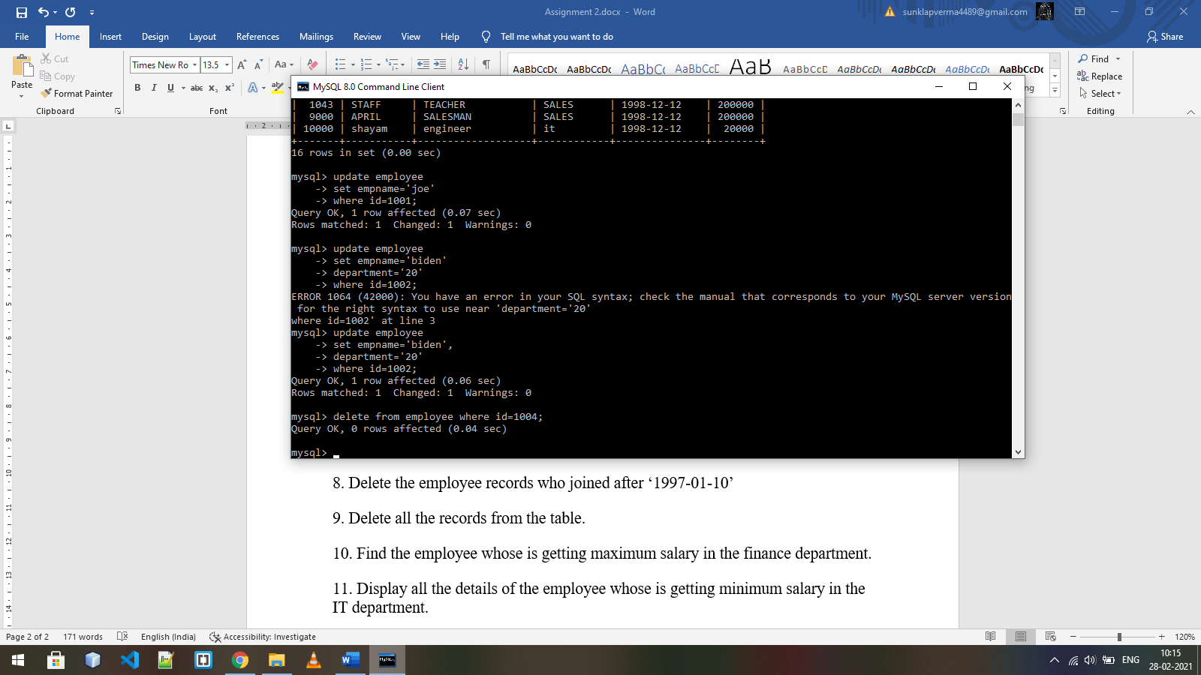

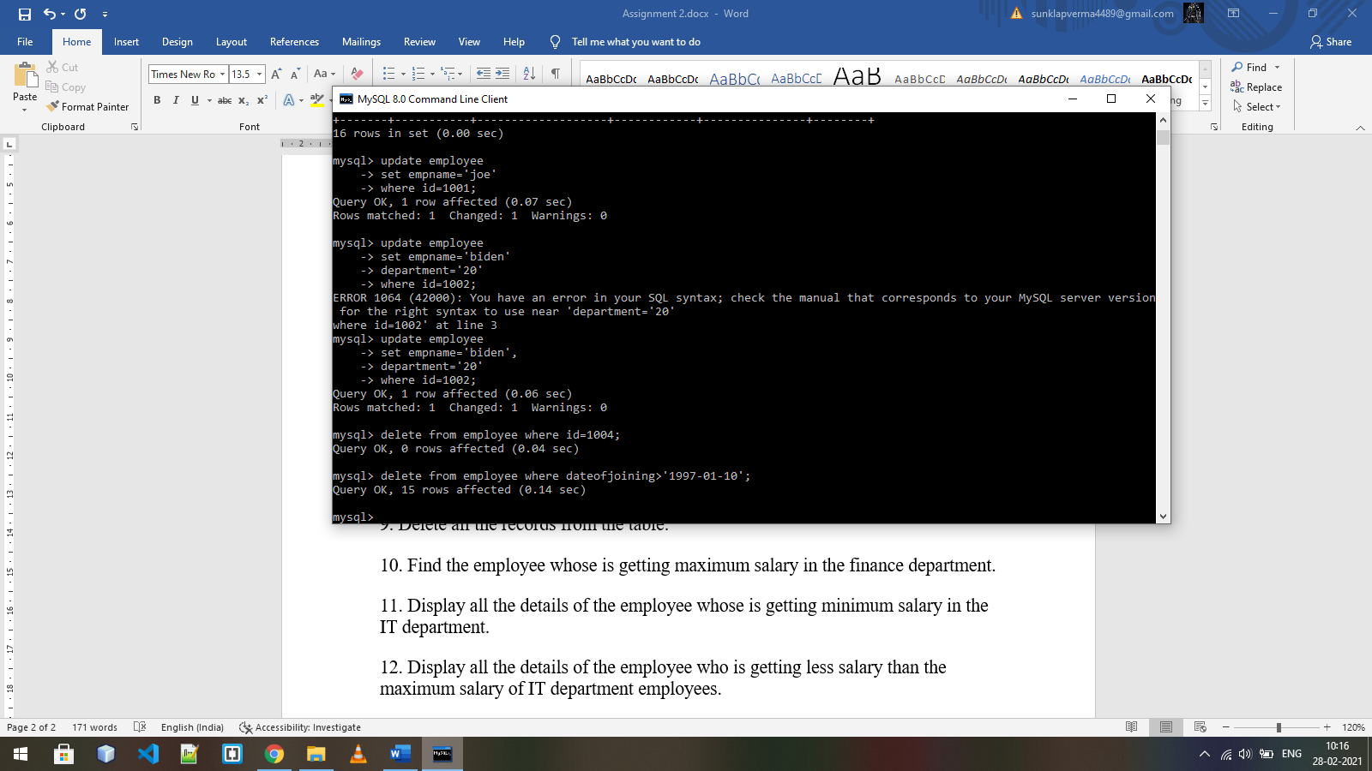8. Delete the employee records who joined after ‘1997-01-10’

9. Delete all the records from the table.

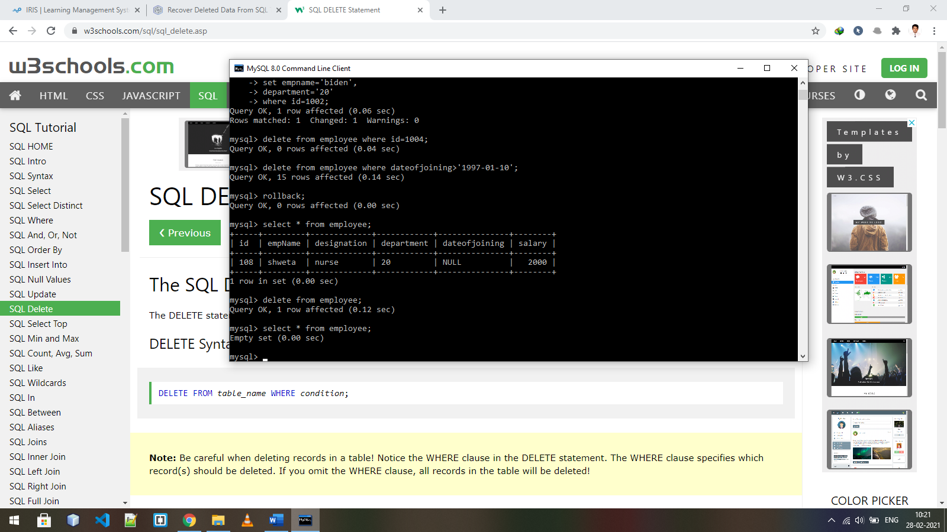  
10. Find the employee whose is getting maximum salary in the finance department.

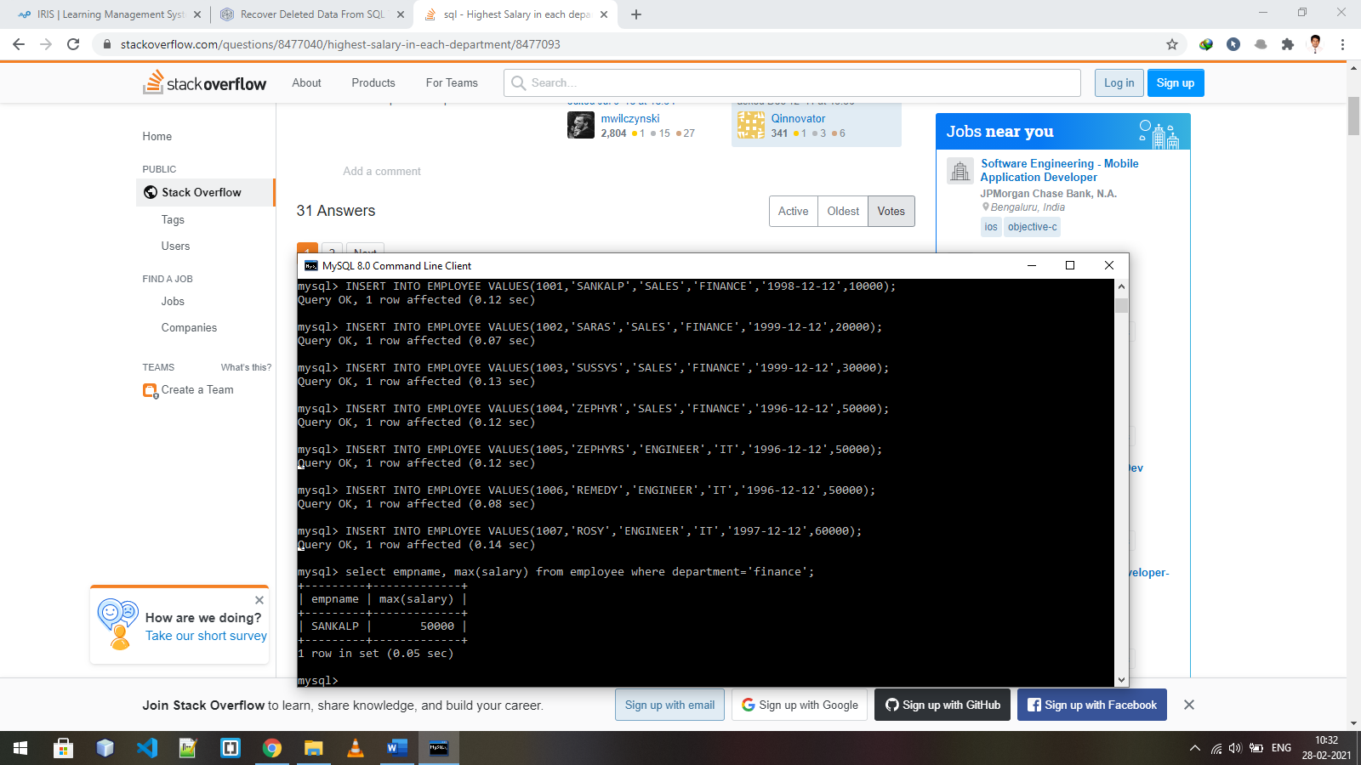

11. Display all the details of the employee whose is getting minimum salary in the IT department.

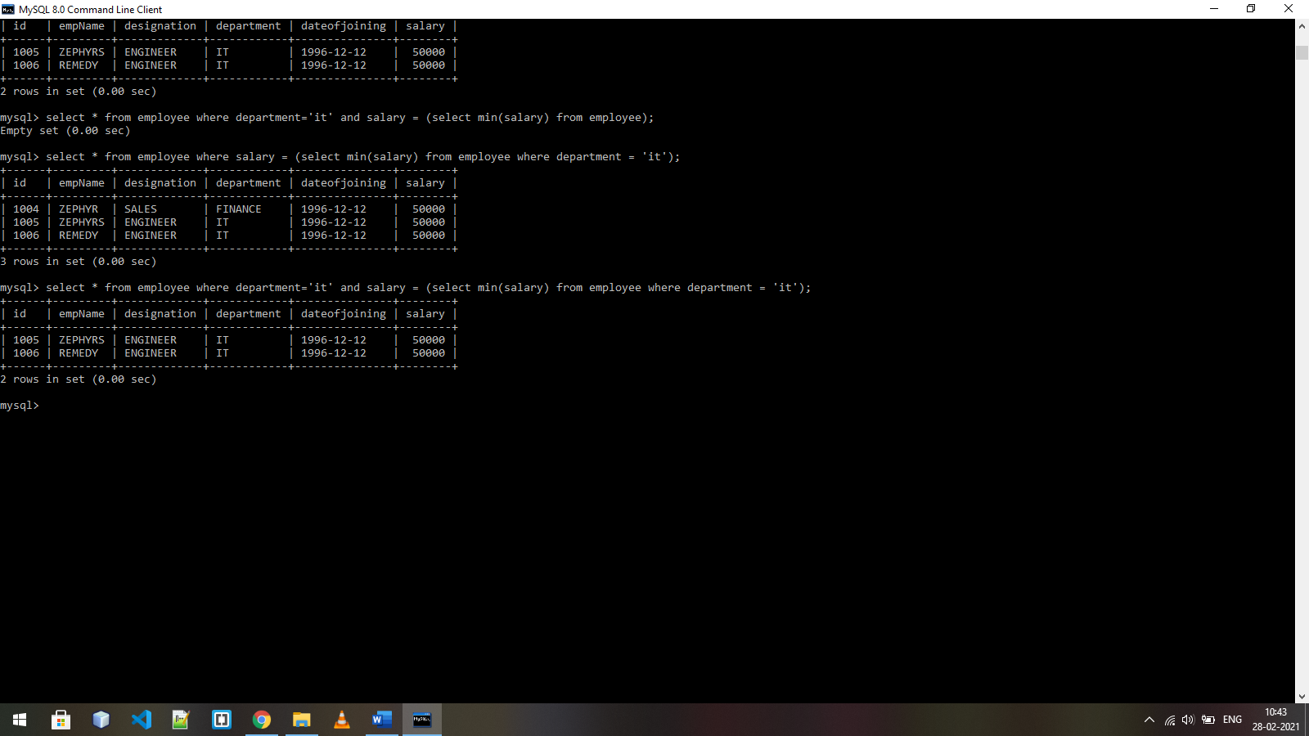  
12. Display all the details of the employee who is getting less salary than the maximum salary of IT department employees.

